**Activity 9.1– Walkthrough a VLSM Addressing Scheme**

**Topology**

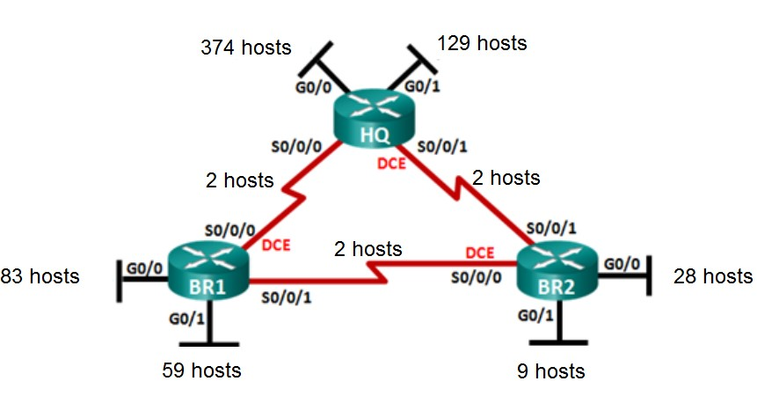

**Objectives**



**Part 1: Examine Network Requirements**

**Part 2: Design the VLSM Address Scheme**

**Background / Scenario**

Variable Length Subnet Mask (VLSM) was designed to avoid wasting IP addresses. With VLSM, a network is subnetted and then re-subnetted. This process can be repeated multiple times to create subnets of various sizes based on the number of hosts required in each subnet. Effective use of VLSM requires address planning.

In this lab, use the 172.16.4.0/22 network address to develop an address scheme for the network displayed in the topology diagram. Imagine that this network has been provided to you by your ISP. VLSM is used to meet the IPv4 addressing requirements. After you have designed the VLSM address scheme, you will configure the interfaces on the routers with the appropriate IP address information.

Note: Serial cables have two ends, one of which is called DCE and the other is called DTE. The DCE end will provide the clock and other control signals to the DTE end.

# Part 1: Examine Network Requirements

In Part 1, you will examine the network requirements to develop a VLSM address scheme for the network displayed in the topology diagram using the 172.16.4.0/22 network address.

. All rights reserved. This document is Cisco Public.

**Step 1: Determine how many host addresses and subnets are available.**

How many host addresses are available in a /22 network? 1022 (2^10 -2 = 1024 – 2)

How many networks are available in the 172.16.4.0/22 network if only the 3rd octet is used? 4

With a /22 prefix the subnet mask is: 11111111 . 11111111 . 11111100 . 00000000 The magic number is: 4

The starting network is: 172.16.4.0 The next network starts at: 172.16.8.0

This leaves the following 4 possible networks:

172.16.4.0 10101100 . 00010000 . 00000100 . 00000000

172.16.5.0 10101100 . 00010000 . 00000101 . 00000000

172.16.6.0 10101100 . 00010000 . 00000110 . 00000000

172.16.7.0 10101100 . 00010000 . 00000111 . 00000000

How many hosts can each of these networks support? 256

What is the total number of host addresses needed in the topology diagram? 688

HQ-G0/0: 374 +

HQ-G0/1: 129 +

BR1-G0/0: 83 +

BR1-G0/1: 59 +

BR2-G0/1: 9 +

BR2-G0/0: 28 +

HQ_To_BR1: 2 +

BR1_To_BR2: 2 +

BR2_To_HQ: 2

What is the minimum number of bits needed to support all the hosts? 10

Given that many host-bits, how many bits are left for the network and subnets? 22

What is the subnet mask for a /22 network? 255.255.252.0

What is the binary for the /22 subnet mask? 11111111 . 11111111 . 11111100 . 00000000

What is the binary for IP address 172.16.4.0: 10101100 . 00010000 . 00000100 . 00000000 How many subnets are needed in the network topology? 9 HQ-G0/0:

HQ-G0/1

BR1-G0/0

BR1-G0/1

BR2-G0/1

BR2-G0/0

HQ-S0/0/0_To_BR1_S/0/0/0

BR1-S0/0/1_To_BR2-S/0/0/0

BR2-S0/0/1_To_HQ-S0/0/1

**Step 2: Determine the largest subnet.**

|  |  |
| --- | --- |
| What is the subnet name of the largest subnet? | HQ-G0/0 |
| How many IP addresses are required in the largest subnet? | 374 |
| How many bits are required to support that many hosts? | 9 (2^9 = 512) |
| How many hosts can that many bits actually support? | 510 (2^9 – 2) |
| What subnet mask can support that many host addresses? | /23 |

## /23 11111111 . 1111111 . 11111110 . 00000000 ^ (2^9 = 512)

How many actual host addresses can that subnet mask support? 510 (512 – 2)

Can you subnet the 172.16.4.0/22 network address to support this subnet? Yes What are the two network addresses that would result from this subnetting?

|  |  |  |
| --- | --- | --- |
| Network address 1: | Decimal: | 172.16.4.0/23 |
|  | Binary: | **10101100 . 00010000 . 00000100 . 00000000** |
|  | Subnet mask: | **11111111 . 11111111 . 11111110 . 00000000** |
|  | First host address: | **10101100 . 00010000 . 00000100 . 00000001** |
|  | Decimal: | 172.16.4.1 |
|  | Last host address: | **10101100 . 00010000 . 00000101 . 11111110** |
|  | Decimal: | 172.16.5.254 |
|  | Broadcast address: | **10101100 . 00010000 . 00000101 . 11111111** |
|  | Decimal: | 172.16.5.255 |
| Network address 2: | Decimal: | 172.16.6.0/23 |
|  | Binary: | **10101100 . 00010000 . 00000110 . 00000000** |
|  | Subnet mask: | **11111111 . 11111111 . 11111110 . 00000000** |
|  | First host address: | **10101100 . 00010000 . 00000110 . 00000001** |
|  | Decimal: | 172.16.6.1 |
|  | Last host address: | **10101100 . 00010000 . 00000111 . 11111110** |
|  | Decimal: | 172.16.7.254 |
|  | Broadcast address: | **10101100 . 00010000 . 00000111 . 11111111** |
|  | Decimal: | 172.16.7.255 |

Use the first network address (172.16.4.0/23) for this subnet. That leaves the second network (172.16.6.0/23) with up to 510 available IP addresses for further subnetting.

**Step 3: Determine the second largest subnet.**

|  |  |  |
| --- | --- | --- |
| What is the subnet name for the next largest subnet? |  | HQ-G0/1 |
| How many IP addresses are required in the next |  | 129 |
| How hosts? |  | 8 (2^8 = 256) |
| How many hosts can that many bits actually support? |  | 254 (2^8 – 2) |
| What subnet mask can support that many host addresses? |  | /24 |

## /24 11111111 . 1111111 . 11111111 . 00000000 ^ (2^8 = 256)

How many actual host addresses can that subnet mask support? 254 (256 – 2) Can you subnet the remaining network from Step 2 (172.16.6.0/23) to support this subnet?

|  |  |
| --- | --- |
| Yes, the remaining subnet (/23) can support 510 possible hosts. Splitting this in two gives us two further | |
| subnets with up to 254 hosts each. |  |

What are the two network addresses that would result from this subnetting?

|  |  |  |
| --- | --- | --- |
| Network address 1: | Decimal: | 172.16.6.0/24 |
|  | Binary: | **10101100 . 00010000 . 00000110 . 00000000** |
|  | Subnet mask: | **11111111 . 11111111 . 11111111 . 00000000** |
|  | First host address: | **10101100 . 00010000 . 00000110 . 00000001** |
|  | Decimal: | 172.16.6.1 |
|  | Last host address: | **10101100 . 00010000 . 00000110 . 11111110** |
|  | Decimal: | 172.16.6.254 |
|  | Broadcast address: | **10101100 . 00010000 . 00000110 . 11111111** |
|  | Decimal: | 172.16.6.255 |
| Network address 2: | Decimal: | 172.16.7.0/24 |
|  | Binary: | **10101100 . 00010000 . 00000111 . 00000000** |
|  | Subnet mask: | **11111111 . 11111111 . 11111111 . 00000000** |
|  | First host address: | **10101100 . 00010000 . 00000111 . 00000001** |
|  | Decimal: | 172.16.7.1 |
|  | Last host address: | **10101100 . 00010000 . 00000111 . 11111110** |
|  | Decimal: | 172.16.7.254 |
|  | Broadcast address: | **10101100 . 00010000 . 00000111 . 11111111** |
|  | Decimal: | 172.16.7.255 |

Use the first network address (172.16.6.0/24) for this subnet. That leaves the second network (172.16.7.0/24) with up to 510 available IP addresses for further subnetting.

**Step 4: (third) largest subnet.**

|  |  |  |
| --- | --- | --- |
| What is the subnet name for the next largest subnet? |  | BR1-G0/0 |
| How many IP addresses are required in the next |  | 83 |
| How many bits are required to support that many hosts? |  | 7 (2^7 = 128) |
| How many hosts can that many bits actually support? |  | 126 (2^7 – 2) |
| What subnet mask can support that many host addresses? |  | /25 |

## /25 11111111 . 1111111 . 11111111 . 10000000 ^ (2^7 = 128)

How many actual host addresses can that subnet mask support? 126 (128 – 2) Can you subnet the remaining network from Step 3 (172.16.7.0/24) to support this subnet?

|  |  |
| --- | --- |
| Yes, the remaining subnet (/24) can support 256 possible hosts. Splitting this in two gives us two further | |
| subnets with up to 126 hosts each. |  |

What are the two network addresses that would result from this subnetting?

|  |  |  |
| --- | --- | --- |
| Network address 1: | Decimal: | 172.16.7.0/25 |
|  | Binary: | **10101100 . 00010000 . 00000111 . 00000000** |
|  | Subnet mask: | **11111111 . 11111111 . 11111111 . 10000000** |
|  | First host address: | **10101100 . 00010000 . 00000111 . 00000001** |
|  | Decimal: | 172.16.7.1 |
|  | Last host address: | **10101100 . 00010000 . 00000111 . 01111110** |
|  | Decimal: | 172.16.7.126 |
|  | Broadcast address: | **10101100 . 00010000 . 00000111 . 01111111** |
|  | Decimal: | 172.16.7.127 |
| Network address 2: | Decimal: | 172.16.7.128/25 |
|  | Binary: | **10101100 . 00010000 . 00000111 . 10000000** |
|  | Subnet mask: | **11111111 . 11111111 . 11111111 . 10000000** |
|  | First host address: | **10101100 . 00010000 . 00000111 . 10000001** |
|  | Decimal: | 172.16.7.129 |
|  | Last host address: | **10101100 . 00010000 . 00000111 . 11111110** |
|  | Decimal: | 172.16.7.254 |
|  | Broadcast address: | **10101100 . 00010000 . 00000111 . 11111111** |
|  | Decimal: | 172.16.7.255 |

Use the first network address (172.16.7.0/25) for this subnet. That leaves the second network (172.16.7.128/25) with up to 128 available IP addresses for further subnetting.

**Step 5: (fourth) largest subnet.**

|  |  |  |
| --- | --- | --- |
| What is the subnet name for the next largest subnet? |  | BR1-G0/1 |
| How many IP addresses are required in the next |  | 59 |
| How many bits are required to support that many hosts? |  | 6 (2^6 = 64) |
| How many hosts can that many bits actually support? |  | 62 (2^6 – 2) |
| What subnet mask can support that many host addresses? |  | /26 |

## /26 11111111 . 1111111 . 11111111 . 11000000 ^ (2^6 = 64)

How many actual host addresses can that subnet mask support? 62 (64 – 2) Can you subnet the remaining network from Step 4 (172.16.7.128/25) to support this subnet?

|  |  |
| --- | --- |
| Yes, the remaining subnet (/25) can support 128 possible hosts. Splitting this in two gives us two further | |
| subnets with up to 64 hosts each. |  |

What are the two network addresses that would result from this subnetting?

|  |  |  |
| --- | --- | --- |
| Network address 1: | Decimal: | 172.16.7.128/26 |
|  | Binary: | **10101100 . 00010000 . 00000111 . 10000000** |
|  | Subnet mask: | **11111111 . 11111111 . 11111111 . 11000000** |
|  | First host address: | **10101100 . 00010000 . 00000111 . 10000001** |
|  | Decimal: | 172.16.7.129 |
|  | Last host address: | **10101100 . 00010000 . 00000111 . 10111110** |
|  | Decimal: | 172.16.7.190 |
|  | Broadcast address: | **10101100 . 00010000 . 00000111 . 10111111** |
|  | Decimal: | 172.16.7.191 |
| Network address 2: | Decimal: | 172.16.7.192/26 |
|  | Binary: | **10101100 . 00010000 . 00000111 . 11000000** |
|  | Subnet mask: | **11111111 . 11111111 . 11111111 . 11000000** |
|  | First host address: | **10101100 . 00010000 . 00000111 . 11000001** |
|  | Decimal: | 172.16.7.193 |
|  | Last host address: | **10101100 . 00010000 . 00000111 . 11111110** |
|  | Decimal: | 172.16.7.254 |
|  | Broadcast address: | **10101100 . 00010000 . 00000111 . 11111111** |
|  | Decimal: | 172.16.7.255 |

Use the first network address (172.16.7.128/26) for this subnet. That leaves the second network (172.16.7.192/26) with up to 64 available IP addresses for further subnetting.

**Step 6: (fifth) largest subnet.**

|  |  |  |
| --- | --- | --- |
| What is the subnet name for the next largest subnet? |  | BR2-G0/0 |
| How many IP addresses are required in the next |  | 28 |
| How many bits are required to support that many hosts? |  | 5 (2^5 = 32) |
| How many hosts can that many bits actually support? |  | 30 (2^5 – 2) |
| What subnet mask can support that many host addresses? |  | /27 |
| **/27**  **11111111 . 1111111 . 11111111 . 11100000** | |

## ^ (2^5 = 32)

How many actual host addresses can that subnet mask support? 30 (32 – 2) Can you subnet the remaining network from Step 5 (172.16.7.192/26) to support this subnet?

|  |  |
| --- | --- |
| Yes, the remaining subnet (/26) can support 64 possible hosts. Splitting this in two gives us two further | |
| subnets with up to 32 hosts each. |  |

What are the two network addresses that would result from this subnetting?

|  |  |  |
| --- | --- | --- |
| Network address 1: | Decimal: | 172.16.7.192/27 |
|  | Binary: | **10101100 . 00010000 . 00000111 . 11000000** |
|  | Subnet mask: | **11111111 . 11111111 . 11111111 . 11100000** |
|  | First host address: | **10101100 . 00010000 . 00000111 . 11000001** |
|  | Decimal: | 172.16.7.193 |
|  | Last host address: | **10101100 . 00010000 . 00000111 . 11011110** |
|  | Decimal: | 172.16.7.222 |
|  | Broadcast address: | **10101100 . 00010000 . 00000111 . 11011111** |
|  | Decimal: | 172.16.7.223 |
| Network address 2: | Decimal: | 172.16.7.224/27 |
|  | Binary: | **10101100 . 00010000 . 00000111 . 11100000** |
|  | Subnet mask: | **11111111 . 11111111 . 11111111 . 11100000** |
|  | First host address: | **10101100 . 00010000 . 00000111 . 11100001** |
|  | Decimal: | 172.16.7.225 |
|  | Last host address: | **10101100 . 00010000 . 00000111 . 11111110** |
|  | Decimal: | 172.16.7.254 |
|  | Broadcast address: | **10101100 . 00010000 . 00000111 . 11111111** |
|  | Decimal: | 172.16.7.255 |

Use the first network address (172.16.7.192/27) for this subnet. That leaves the second network (172.16.7.224/27) with up to 32 available IP addresses for further subnetting.

**Step 7: (sixth) largest subnet.**

|  |  |  |
| --- | --- | --- |
| What is the subnet name for the next largest subnet? |  | BR2-G0/1 |
| How many IP addresses are required in the next |  | 9 |
| How many bits are required to support that many hosts? |  | 4 (2^4 = 16) |
| How many hosts can that many bits actually support? |  | 14 (2^4 – 2) |
| What subnet mask can support that many host addresses? |  | /28 |
| **/28**  **11111111 . 1111111 . 11111111 . 11110000** | |

## ^ (2^4 = 16)

How many actual host addresses can that subnet mask support? 14 (16 – 2) Can you subnet the remaining network from Step 5 (172.16.7.224/27) to support this subnet?

|  |  |
| --- | --- |
| Yes, the remaining subnet (/27) can support 32 possible hosts. Splitting this in two gives us two further | |
| subnets with up to 16 hosts each. |  |

What are the two network addresses that would result from this subnetting?

|  |  |  |
| --- | --- | --- |
| Network address 1: | Decimal: | 172.16.7.224/28 |
|  | Binary: | **10101100 . 00010000 . 00000111 . 11100000** |
|  | Subnet mask: | **11111111 . 11111111 . 11111111 . 11110000** |
|  | First host address: | **10101100 . 00010000 . 00000111 . 11100001** |
|  | Decimal: | 172.16.7.224 |
|  | Last host address: | **10101100 . 00010000 . 00000111 . 11101110** |
|  | Decimal: | 172.16.7.238 |
|  | Broadcast address: | **10101100 . 00010000 . 00000111 . 11101111** |
|  | Decimal: | 172.16.7.239 |
| Network address 2: | Decimal: | 172.16.7.240/28 |
|  | Binary: | **10101100 . 00010000 . 00000111 . 11110000** |
|  | Subnet mask: | **11111111 . 11111111 . 11111111 . 11110000** |
|  | First host address: | **10101100 . 00010000 . 00000111 . 11110001** |
|  | Decimal: | 172.16.7.241 |
|  | Last host address: | **10101100 . 00010000 . 00000111 . 11111110** |
|  | Decimal: | 172.16.7.254 |
|  | Broadcast address: | **10101100 . 00010000 . 00000111 . 11111111** |
|  | Decimal: | 172.16.7.255 |

Use the first network address (172.16.7.224/28) for this subnet. That leaves the second network (172.16.7.240/28) with up to 16 available IP addresses for further subnetting.

**Step 8: Determine the (three) subnets needed to support the serial links.**

We will need to support three router to router networks (serial links). Each of these networks consists of 2 routers (actual hosts). What are the subnet names for the three remaining router to router networks?

HQ-S0/0/0_To_BR1_S/0/0/0

BR1-S0/0/1_To_BR2-S/0/0/0

BR2-S0/0/1_To_HQ-S0/0/1

|  |  |
| --- | --- |
| How many IP addresses are required in each of these subnets? | 2 |
| How many bits are required to support that many hosts? | 2 (2^2 = 4) |
| How many hosts can that many bits actually support? | 2 (2^2 – 2) |
| What subnet mask can support that many host addresses?  **/30**  **11111111 . 1111111 . 11111111 . 11111100** | /30 |

## ^ (2^2 = 4)

How many actual host addresses can that subnet mask support? 2 (4 – 2)

Can you subnet the remaining network from Step 5 (172.16.7.240/28) to support these three subnets?

|  |  |
| --- | --- |
| Yes, the remaining subnet (/28) can support 16 possible hosts. We need 3 x 4 = 12 hosts to support the three | |
| router to router networks. The remaining /28 subnet could support up to 4 /30 subnets. |  |

What are the four network addresses that would result from this subnetting?

|  |  |  |
| --- | --- | --- |
| Network address 1: | Decimal: | 172.16.7.240/30 |
|  | Binary: | **10101100 . 00010000 . 00000111 . 11111000** |
|  | Subnet mask: | **11111111 . 11111111 . 11111111 . 11111100** |
|  | First host address: | **10101100 . 00010000 . 00000111 . 11110001** |
|  | Decimal: | 172.16.7.241 |
|  | Last host address: | **10101100 . 00010000 . 00000111 . 11110010** |
|  | Decimal: | 172.16.7.242 |
|  | Broadcast address: | **10101100 . 00010000 . 00000111 . 11110011** |
|  | Decimal: | 172.16.7.243 |
| Network address 2: | Decimal: | 172.16.7.244/30 |
|  | Binary: | **10101100 . 00010000 . 00000111 . 11110100** |
|  | Subnet mask: | **11111111 . 11111111 . 11111111 . 11111100** |
|  | First host address: | **10101100 . 00010000 . 00000111 . 11110101** |
|  | Decimal: | 172.16.7.245 |
|  | Last host address: | **10101100 . 00010000 . 00000111 . 11110110** |
|  | Decimal: | 172.16.7.246 |
|  | Broadcast address: | **10101100 . 00010000 . 00000111 . 11110111** |
|  | Decimal: | 172.16.7.247 |

|  |  |  |
| --- | --- | --- |
| Network address 3: | Decimal: | 172.16.7.248/30 |
|  | Binary: | **10101100 . 00010000 . 00000111 . 11111000** |
|  | Subnet mask: | **11111111 . 11111111 . 11111111 . 11111100** |
|  | First host address: | **10101100 . 00010000 . 00000111 . 11111001** |
|  | Decimal: | 172.16.7.249 |
|  | Last host address: | **10101100 . 00010000 . 00000111 . 11111010** |
|  | Decimal: | 172.16.7.250 |
|  | Broadcast address: | **10101100 . 00010000 . 00000111 . 11111011** |
|  | Decimal: | 172.16.7.251 |
| Network address 4: | Decimal: | 172.16.7.252/30 |
|  | Binary: | **10101100 . 00010000 . 00000111 . 11111100** |
|  | Subnet mask: | **11111111 . 11111111 . 11111111 . 11111100** |
|  | First host address: | **10101100 . 00010000 . 00000111 . 11111101** |
|  | Decimal: | 172.16.7.253 |
|  | Last host address: | **10101100 . 00010000 . 00000111 . 11111110** |
|  | Decimal: | 172.16.7.254 |
|  | Broadcast address: | **10101100 . 00010000 . 00000111 . 11111111** |
|  | Decimal: | 172.16.7.255 |

8a. Use the first network address (172.16.7.240/30) for HQ-S0/0/0_To_BR1_S/0/0/0.

8b. Use the second network address (172.16.7.244/30) for BR2-S0/0/1_To_HQ-S0/0/1.

8c. Use the third network address (172.16.7.248/30) for BR1-S0/0/1_To_BR2-S/0/0/0.

8d. The remaining (fourth) network address (172.16.7.252/30) is unused for now.

# Part 2: Design the VLSM Address Scheme

**Step 1: Calculate the subnet information.**

|  |  |  |  |  |  |  |  |
| --- | --- | --- | --- | --- | --- | --- | --- |
| **Subnet Description** | **Number of**  **Hosts**  **Needed** | **Subnet size** | **Network Address /CIDR** | **First Host Address** | **Last Host**  **Address** | **Broadcast Address** | **Step**  **#** |
| HQ G0/0 | 374 | 512 | 172.16.4.0/23 | 172.16.4.1 | 172.16.5.254 | 172.16.5.255 | 2 |
| HQ G0/1 | 129 | 256 | 172.16.6.0/24 | 172.16.6.1 | 172.16.6.254 | 172.16.6.255 | 3 |
| BR1 G0/0 | 83 | 128 | 172.16.7.0/25 | 172.16.7.1 | 172.16.7.126 | 172.16.7.127 | 4 |
| BR1 G0/1 | 59 | 64 | 172.16.7.128/26 | 172.16.7.129 | 172.16.7.190 | 172.16.7.191 | 5 |
| BR2 G0/0 | 28 | 32 | 172.16.7.192/27 | 172.16.7.193 | 172.16.7.222 | 172.16.7.223 | 6 |
| BR2 G0/1 | 9 | 16 | 172.16.7.224/28 | 172.16.7.225 | 172.16.7.238 | 172.16.7.239 | 7 |
| HQ S0/0/0 – BR1 S0/0/0 | 2 | 4 | 172.16.7.240/30 | 172.16.7.241 | 172.16.7.242 | 172.16.7.243 | 8a |
| HQ S0/0/1 – BR2 S0/0/1 | 2 | 4 | 172.16.7.244/30 | 172.16.7.245 | 172.16.7.246 | 172.16.7.247 | 8b |
| BR1 S0/0/1 – BR2 S0/0/0 | 2 | 4 | 172.16.7.248/30 | 172.16.7.249 | 172.16.7.250 | 172.16.7.251 | 8c |

**Step 2: Complete the device interface address table.**

Assign the first host address in the subnet to the Ethernet interfaces.

|  |  |  |  |  |  |  |
| --- | --- | --- | --- | --- | --- | --- |
| **Device** | **Interface** | **IP Address** | **Prefix** | **Subnet mask** | **Connects**  **to** | **Step #** |
| HQ | G0/0 | 172.16.4.1 | /23 | 255.255.254.0 | |  |  | | --- | --- | | 374 Host | | | LAN |  | | 2 |
| G0/1 | 172.16.6.1 | /24 | 255.255.255.0 | |  |  | | --- | --- | | 129 Host | | | LAN |  | | 3 |
| S0/0/0 | 172.16.7.241 | /30 | 255.255.255.252 | BR1 S0/0/0 | 8a |
| S0/0/1 | 172.16.7.250 | /30 | 255.255.255.252 | BR2 S0/0/1 | 8c |
| BR1 | G0/0 | 172.16.7.1 | /25 | 255.255.255.128 | |  |  | | --- | --- | | 83 Host | | | LAN |  | | 4 |
| G0/1 | 172.16.7.129 | /26 | 255.255.255.192 | |  |  | | --- | --- | | 59 Host | | | LAN |  | | 5 |
| S0/0/0 | 172.16.7.242 | /30 | 255.255.255.252 | HQ S0/0/0 | 8a |
| S0/0/1 | 172.16.7.245 | /30 | 255.255.255.252 | BR2 S0/0/0 | 8b |
| BR2 | G0/0 | 172.16.193 | /27 | 255.255.255.224 | |  |  | | --- | --- | | 28 Host | | | LAN |  | | 6 |
| G0/1 | 172.16.7.225 | /28 | 255.255.255.240 | 9 Host LAN | 7 |
| S0/0/0 | 172.16.7.246 | /30 | 255.255.255.252 | BR1 S0/0/1 | 8b |
| S0/0/1 | 172.16.7.249 | /30 | 255.255.255.252 | HQ S0/0/1 | 8c |

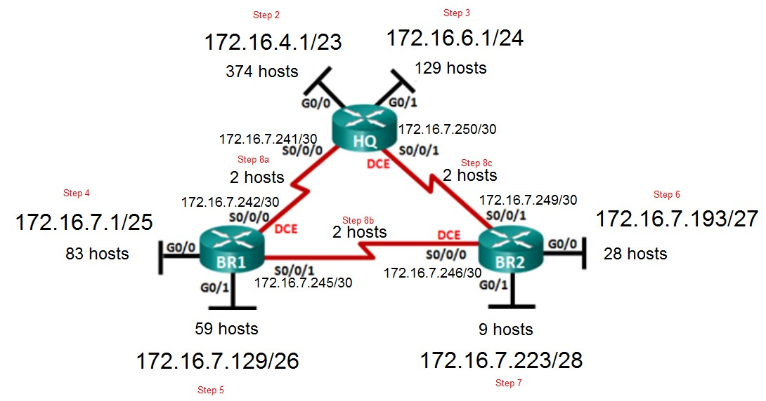

Subnet work allocation diagram:

